Questions which keep us up at night

* Is there any market for this app? Is there even a need for it?

According to the study done by Michigan State University psychology professor William J. Chopik on people around the world at different ages shows that from age 65 onwards, people value friendship higher than younger. Thus showing the importance of friendship for the elderlies.

Additionally, from our research, we found out that One in five elderly persons in Singapore aged 75 and above show signs of depression, this statistics is taken from the Singapore Longitudinal Ageing Study done in 2012 by the National University of Singapore’s Yong Loo Lin School of Medicine.

The NUS’ Singapore Longitudinal Ageing Study in 2004 found that widowed or divorced persons above 65 were more likely to experience depression (22 per cent) than widowed or divorced persons between the ages of 55 and 65 (13 per cent).

(<https://www.channelnewsasia.com/news/cnainsider/elderly-depression-lonely-dementia-chronic-illness-treatment-10159670>)

Hence, with friendship being important to elderies and with higher amount of elderlies having depression due to being lonely, there is a need for our app as we can help elderlies to widen their social circle so that they will no longer be lonely anymore.

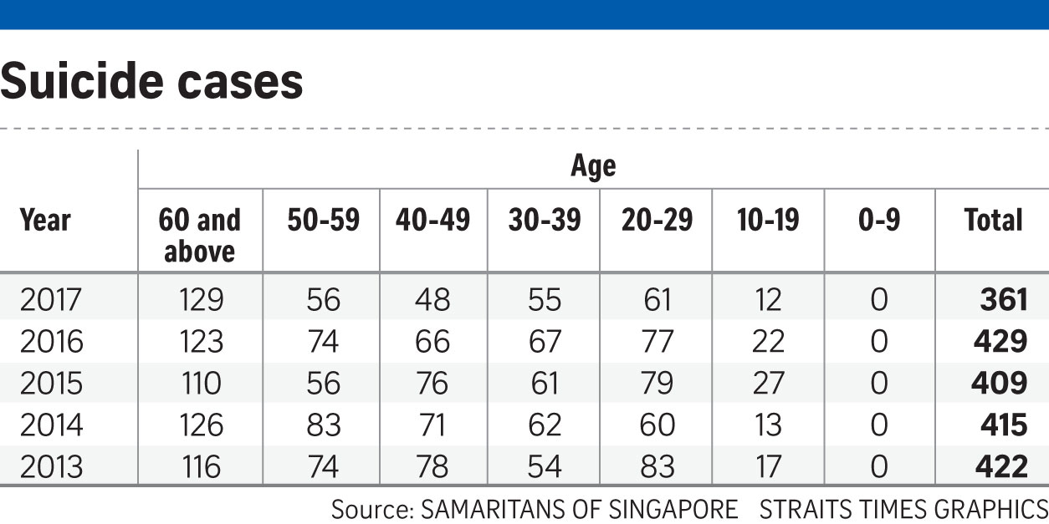

* Will this app really work when social media apps like Facebook (which has an older demographic) exists? How will it compete with Facebook?

Although there are news that Facebook is getting popular among the elderly, there are actually still a lot of elderly that are not comfortable using it. An example from the Today paper is Madam Yang, 59. She has a Facebook account because she is following the trend but she rarely uses it as she is not familiar with the features on Facebook - she does not even know how to change her profile picture.

Even when she read news online, she is unable to join in on the discussions as she does not know how to post comments.

<https://www.todayonline.com/singapore/big-read-feeling-lost-digital-world-some-elderly-shun-technology>

* Is there a demand for this app⇒ Are the elderly that tech advanced that they would have a need/want for an app like this?

The elderly in Singapore will be able to use our app as our app interface is specially catered for the elderlies. With an app interface that is easier for the elderly to comprehend and get used to, the elderlies will be more likely to use our app. In case, the elderlies are to get confused or forget how to use the app, our app have the feature of the on-boarding tutorial which the elderlies will be able to rewatch anytime.

According to IDA Infocomm usage in householdsin 2014 from data collected from 3500 households via face-to-face interviews. 75% of those age 50-59, 31% of those age >=60 surfed the web regularly via their smartphone.

* How will this app benefit the elderly community?

As the people grow older, they will not be as fit as they were when they were younger. Hence, mobility might be an issue for the elderlies. With Ol’Friends, elderlies will be able to make new friends at home and with more friends, they will be happier and is unlikely to fall into depression.

* You talk about a simpler interface, but can’t that be addressed with the changes in Facebook’s settings.

In Facebook’s setting, all the user could do is to filter out things. However, with our app the ui is specifically designed up for the elder so that they will be comfortable using it and is able to get use to using it easily.

* How can we sell our app?

We can sell our app by collaborating with the elderly home/ old folks home to promote our app there. For instance, introducing and teaching the elderlies there how to use the app and they can start by adding their friends at the centre on the app.

* Do similar apps that target the elderly already exist? If yes, how do we differ from them?

Similar apps that target the elderly are: Stitch.

Stitch allows elderlies from all over the world to look for friendship and romance.

For adding friends on stitch, the user cannot search or add their friends, they can only add or view the profile of people that are randomly matched by the app, and the number of profile that the user can view is limited to their rank.

The users of stitch are categorized into basic, bronze, silver, gold and diamond. In order for one to have a higher rank, the user have to pay a sum of money monthly.

Ol’Friends is targeted at the elderly in Singapore, the user of Ol’Friends are able to search for their friends and add them. Additionally, Ol’Friends will recommend people for the user to add as friends based on the hobbies that the users have indicated that they have interest in. Unlike stitch where there is a ranking of membership, Ol’Friends is free for all to use.

* Are we able to deliver a prototype in the given amount of time?

Yes

* What is unique about our app that will make the elderly use it?

Our app is unique in the sense that the user-interface is specially catered for the elderly - with simple design that is clear-cut, colours used that is pleasing to the elderly. Our app also have an onboarding tutorial that the elderly is able to access anytime they want. Lastly, in order to have a neater interface and to solve the issue of the font of the feed being too small for the elderly to see, we implemented the feature of when the elderly clicks on a particular feed the pop-up of the feed with bigger font will appear.